***Graphic Era Hill University***

**Department of Computer Applications**

**Project**

**On**

**Statistics using R Programming Language**



***Submitted To: Submitted By:***

***Mr. Bijesh Dhyani Atul Bisht MCA -1B (1st SEM)***

***Student id: 21561019***

**PROJECT**

**Objective:** To study the R language and its use in the real world. To learn the use of R language to study a given dataset. Determining various statistical information from the dataset which and plotting the various types of graphs easily.

**Description:** We are provided with a dataset on the murders of different state in different region. We will study the sheet and plot various graphs.

• Setting of Working Directory setwd ("M:/rlang/rp")

• Reading of .csv file data < - read.csv("mud1.csv")

• Using ggplot() library

library(ggplot2)

• Using dplyr() library

library(dplyr)

**#histogram**

**ggplot(data, aes(y=state, x=murders))+ geom_bar(stat = "identity")**

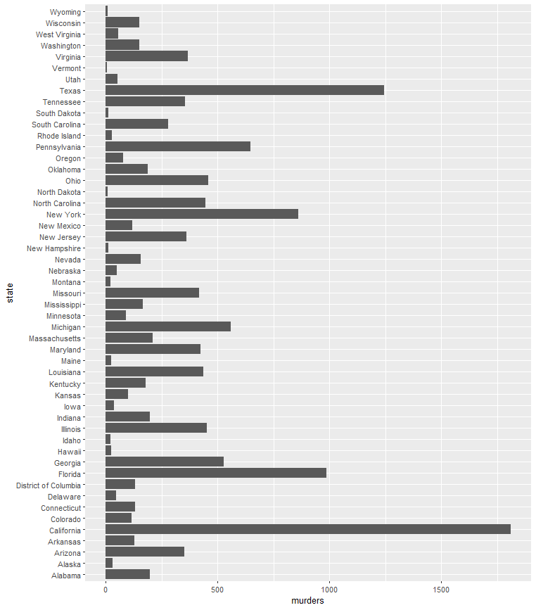

**#histogram**

**ggplot(data, aes(y=state, x=gunmurders))+ geom_bar(stat = "identity")**

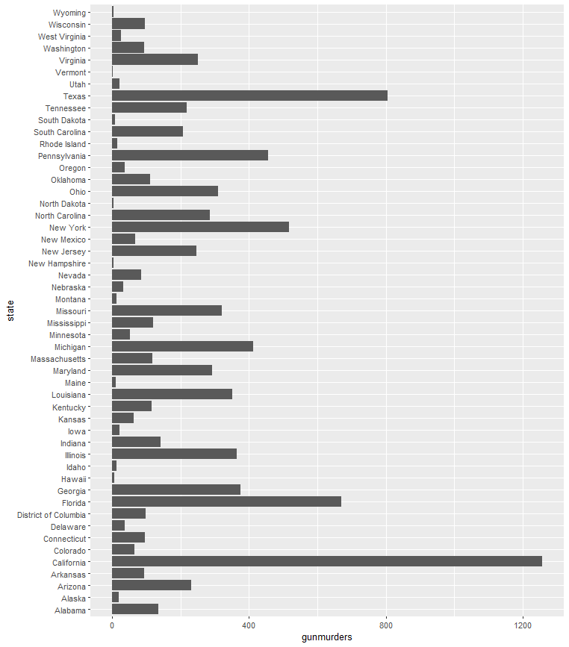

**#piechart**

**ggplot(data,aes(y=murders,fill=region,x=region)) + geom_bar(width=1,stat="identity")+coord_polar("x",start=0)**

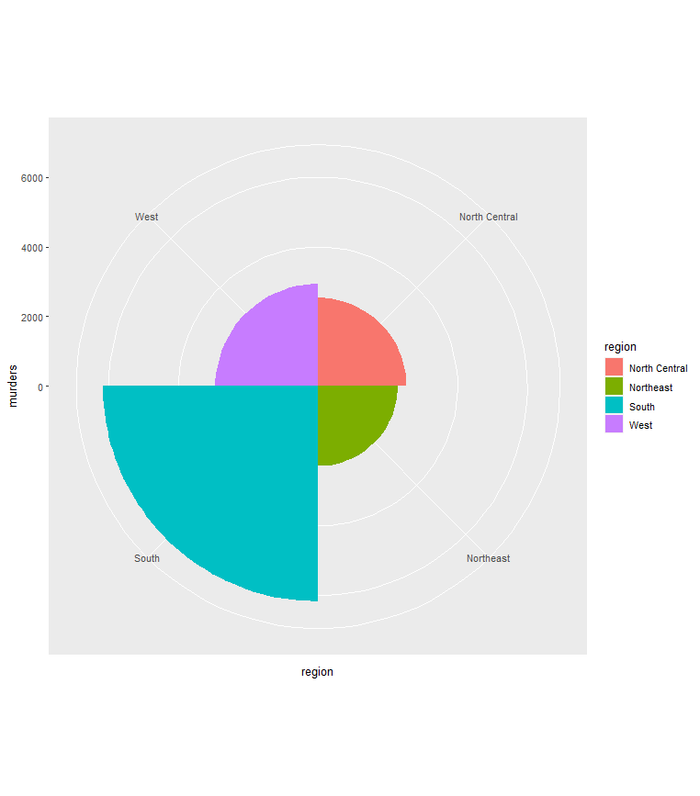

**#scatterplot**

**ggplot(data, aes(y =PopulationDensity, x =murders, group=PopulationDensity, colour=murders)) +geom_line() + geom_point()**

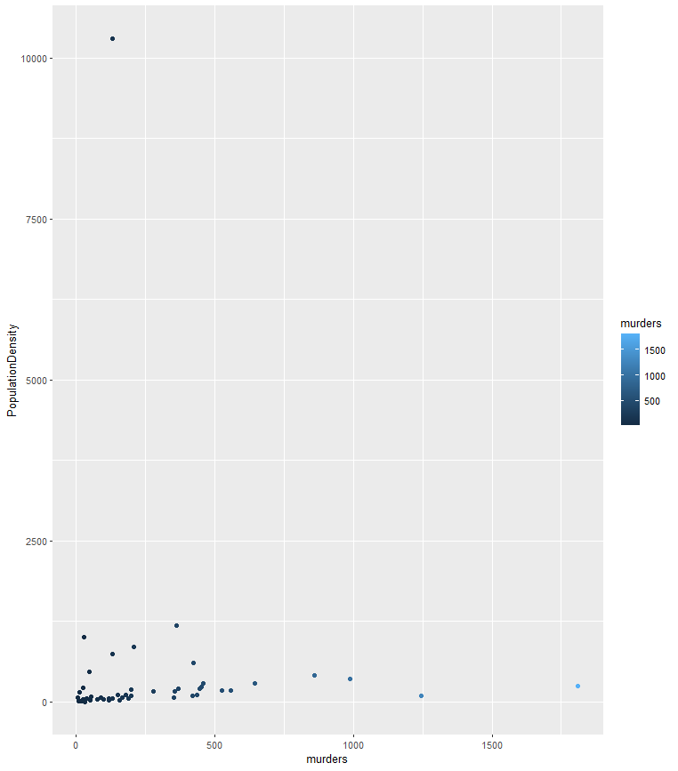

**#boxplot**

**ggplot(data, aes(x= murders, y=region)) +geom_boxplot()**

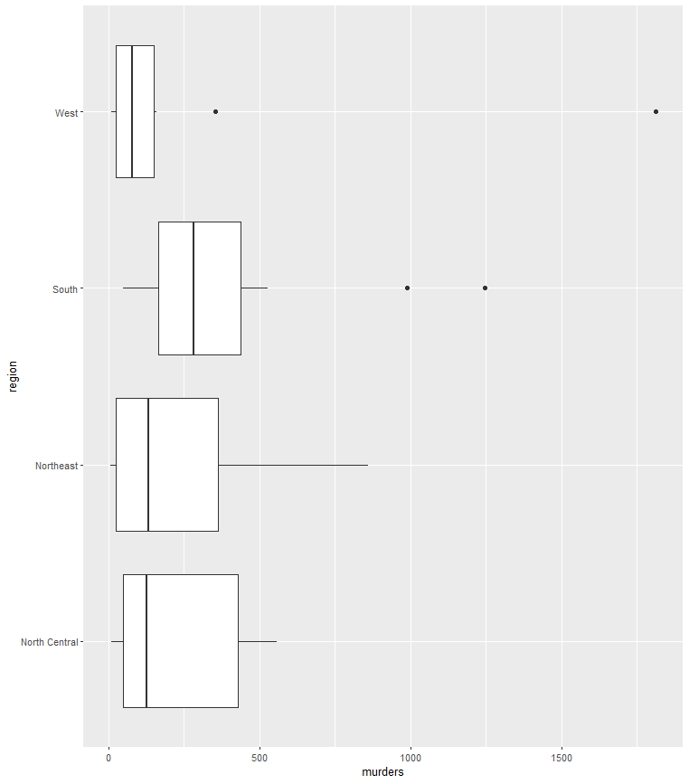

**//Code:**

library(dplyr)

library(ggplot2)

setwd("M:/rlang/rp")

getwd()

data<- read.csv("mud1.csv")

View(data)

head(data)

tail(data)

tail(data,10)

str(data)

summary(data)

data$state.Length

sum(is.na(data))

ggplot(data, aes(y=state, x=murders))+ geom_bar(stat = "identity")

ggplot(data, aes(y=state, x=gunmurders))+ geom_bar(stat = "identity")

ggplot(data, aes(y =PopulationDensity, x =murders, group=PopulationDensity, colour=murders)) +geom_line() + geom_point()

ggplot(data, aes(x= murders, y=region)) +geom_boxplot()

data_size<-factor(data)

str(data_size)

summary(data_size)

levels(data_size)

data_table<-table(data_size)

pie(data_table)

ggplot(data,aes(y=murders,fill=region,x=region)) + geom_bar(width=1,stat="identity")+coord_polar("x",start=0)

//View(data)

